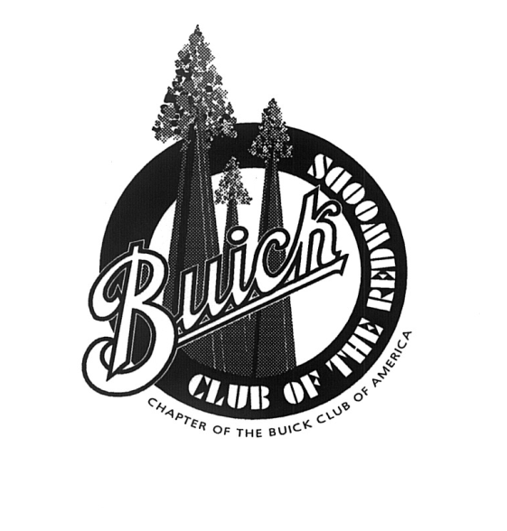

Buick Club of the Redwoods, a Chapter of the Buick Club of America, would like to extend an invitation to you to attend our next monthly meeting. We are a group of Buick owners and lovers, interested in the preservation and enjoyment of Buicks through the ages.
Meetings are held on the 2nd Wednesday of each month at 7:00 p.m. Members start gathering at 6:00 for dinner.

We meet in one of the private rooms at Mary’s Pizza Shack located at 3084 Marlow Road, Santa Rosa in Rosewood Village.

MEMBERSHIP APPLICATION BCA#______________ Exp.____________

(Please Print)

Name(s)______________________________________________________________________

Address______________________________________________________________________

_____________________________________________________________________________

Email address(es) to receive Chapter Newsletter and Chapter event information

_____________________________________________________________________________

Phone: Home________________Cell(s)_______________________Other___________________

List any Buicks owned. Include year, model, body style and any nickname

_____________________________________________________________________________

Other car club affiliations and vehicles

_______________________________________________________________________________

Optional: Birthday(s) or Anniversary __________________________________________________

Please make your $20.00 membership check payable to: Buick Club of the Redwoods.
Mail to: Buick Club of the Redwoods, C/O Richard Kahnberg, 1185 Carr Ave, Santa Rosa, CA 95404

------------------------------------------ Please do not write below this line ----------------------------------

Date paid___________ Amount______Check #_______Date Club Decal Given______________

rev. 07/23/21

